15.04.2017
A few Observations:
The program runs with your Default variables, it does not yet accept variable input (I’ll come back to this). I attach the run report to see that even though I selected EMA faster than SMMA it did not work and variables used your values
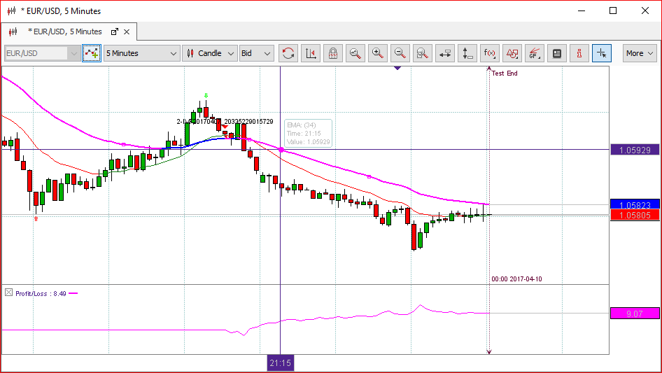
EMA and SMMA, a tricky selection, for the same Period_Value, EMA is faster(closer to the Price), thus for an EMA program , check EMA _period has to be <=SMMA_Period
There is a way to ensure that input variables can be selected:
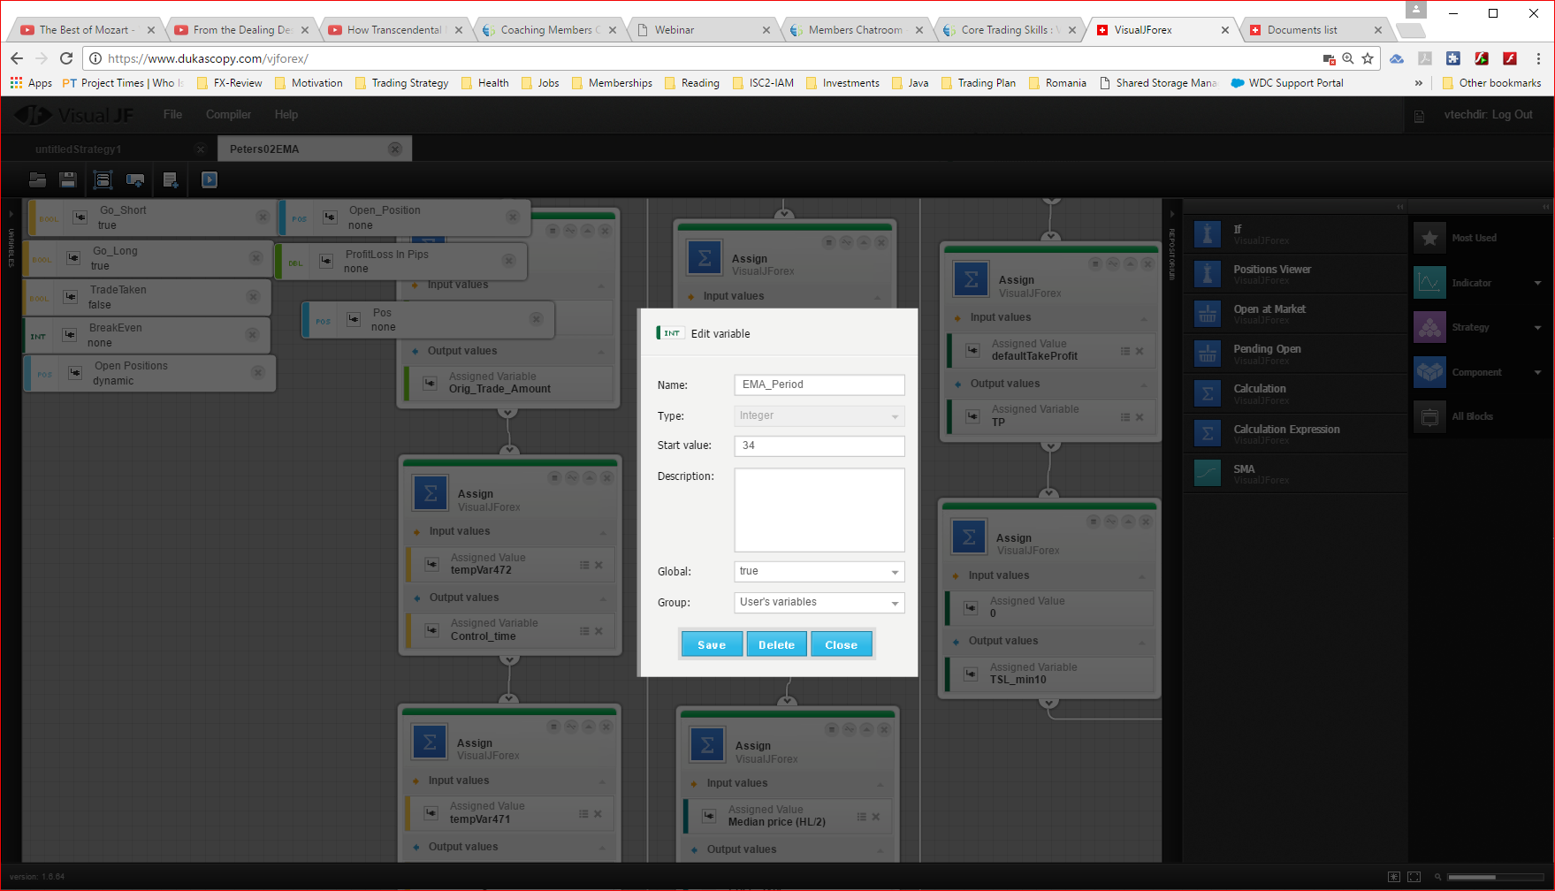
As per your Martingale and MA cross strategies( posted in the forum) and it is to declare the variable at the beginning of “On Candle” and make it Global.
I also noted that it requires negative logic, if it is a Boolean variable, better set it to False to be able to switch it to True, could not change from default True to False.

Question:
If I want to have a position in the opposite direction (Long, whilst the initial position is Short), should I use one of the “Trade Message Position” of “TradeEvent” variables?

In conclusion, I’ll have to edit your program and introduce these conditions, otherwise I cannot be sure what happens. I ran the program in 1min for last month and only got 3 trades, hmm suspect.

I want to have another position opening in the opposite direction whilst the original one is running and only once the original is completed to open another one in the same (original direction), therefore maximum two positions at the same time: one swing (longer timeframe and one scalping on a shorter timeframe)

Question:
I can inspect the positions with “Position Viewer”, how can I identify the positions (if one is Long and the other one is Short), Label. Message? Are those variable applicable only for closed trades?

09.04.2017
EMA(13) and SMMA(21), therefore EMA is faster than SMMA and the condition for Long is Price>EMA>SMMA
EMA(13)=1.06766
SMMA(21)=1.06777
So the condition is not met. Every time this happens multiple orders are started. WHY?

